

Dharmsinh Desai University, Nadiad

Faculty of Technology

Department of Computer Engineering

B. Tech. CE Semester – VI

Subject: (CE – 621) System Design Practice

Project Title:

**Image Processing Applications**

Submitted By:

|  |  |  |
| --- | --- | --- |
| Harshit Tarsariya | CE136 | 18CEUBG080 |
| Janak Vaghasiya | CE142 | 18CEUOS058 |
| Jayesh Zinzuvadia | CE149 | 18CEUBG064 |

Guided by:

**Prof. Apurva A. Mehta**

Assistant Professor

CE Department, DDU Nadiad



*Dharmsinh Desai University, Nadiad*

*Faculty of Technology*

*Department of Computer Engineering*

***CERTIFICATE***

*This is to certify that the project work carried out in*

*the subject of* ***System Design Practice*** *is the bonafide work of*

|  |  |  |  |
| --- | --- | --- | --- |
| ***1)*** | ***Harshit Tarsariya*** | ***CE136*** | ***18CEUBG080*** |
| ***2)*** | ***Janak Vaghasiya*** | ***CE142*** | ***18CEUOS058*** |
| ***3)*** | ***Jayesh Zinzuvadia*** | ***CE149*** | ***18CEUBG064*** |

*of Bachelor of Technology, Semester* ***6*** *in the branch of*

***Computer Engineering*** *during the academic year* ***2020-2021***

|  |  |
| --- | --- |
| *Guide* | *Head of the Department* |
| ***Prof. Apurva A. Mehta***  *Assistant Professor,*  *Department of Computer Engineering,*  *Dharmsinh Desai University,*  *Nadiad* | ***Dr. C. K. Bhensdadia***  *Head of the Department,*  *Department of Computer Engineering,*  *Dharmsinh Desai University,*  *Nadiad* |

Contents

|  |  |  |
| --- | --- | --- |
| Sr. No. | Topic | Page  No. |
| 1. | Abstract | 4 |
| 2. | Introduction | 5 |
| 3. | Software Requirement Specifications | 6 |
| 4. | Design |  |
| 5. | Implementation Details |  |
| 6. | Testing |  |
| 7. | Screenshots |  |
| 8. | Conclusion |  |
| 9. | Limitation and Future Extension |  |
| 10. | Bibliography |  |

1. Abstract

*“A picture is worth a thousand words”*

*-Fred R. Barnard*

*Image Processing Applications* project is itself a bunch of projects. Each sub-project is an application of image processing and computer vision.

The main purpose of this project is to perform various operations on an image and to extract some useful information from it.

Using this extracted information, the system can perform various tasks like it can solve a Sudoku puzzle, a mathematical equation, convert image-text into digital text, read aloud the text, translate the text to another language and can also read the barcode as well.

2. Introduction

*Image Processing Applications* is a collection of various sub-projects. Each sub-project has a common aim i.e. to deal with image processing. So, the main focus of the study is image processing, let’s define it-

***“Image processing is a method to perform some operations on an image, in order to get an enhanced image or to extract some useful information from it.”***

In this system, there is only one end user i.e. one who is going to use this application. Here, the user is required to give an image as input and based on the type of image, the system can perform the following tasks:-

1. Extract text from the image
2. Solves a Sudoku puzzle
3. Solves a mathematical equation
4. Read aloud the text from the image
5. Translate the image-text to some other language
6. Read the barcode and provide name of the product

**Tools, Technology and Platform used:-**

1) Programming Languages: Python and Dart

2) IDE: PyCharm Community Edition, Visual Studio Code

3) Flask Server as backend

4) Python Libraries used:-

OpenCV, NumPy, Tensorflow, Keras, Matplotlib, Pyzbar, Scikit-Learn, Pandas

5) Flutter’s ML kit package

3. Software Requirements Specifications

**3.1 Product Scope**

The system is designed to perform various image processing operations based on the type of image. Scope of the system is global and open for all users. System provides various functionalities to the users like image to text extraction, translating into other language, solving Sudoku puzzle and mathematical equations, barcode to product details and image text to speech.

**3.2 Types of User**

Here, there is only one end-user who is going to use this application.

Image Processing Applications

User

**3.3 System Functional Requirements**

**NOTE:** Here, the functional requirements are listed as module wise

**R1. Image to Text Extraction**

*Description:* This requirement is for converting text from the images into text format/file. System will extract the text from the images and display it on the screen. This text can be copied and one can use it for other purpose.

*Input:* Document or Text Image

*Output:* Displays the image text on the screen

**R2. Sudoku Solver**

*Description:* This requirement is for solving the Sudoku puzzle problem.

*Input:* Sudoku Image

*Output:* Show the final answer of Sudoku puzzle

**R3. Math Equation Solver**

*Description:* This requirement is for solving the mathematical equations like basic arithmetic operations such as addition, multiplication, division and subtraction.

*Input:* Image (containing mathematical equation)

*Output:* Show the answer of the given equation

**R4. Translator**

*Description:* This requirement is for translating the text from the images into some other language.

*Input:* Document Image, Language

*Output:* Show the translated text in the given language fonts

**R5. Text Reader**

*Description:* This requirement is for reading aloud the text from the images.

*Input:* Document or Text Image

*Output:* Machine will read the text from the image

**R6. Barcode to Product Details**

*Description:* This requirement is for identifying the barcode from the image and giving the product name as output from the barcode image.

*Input:* Barcode Image

*Output:* Show the product name belonging to the barcode.

**3.4 Other Non-functional Requirements**

**1) Performance**

The application should run efficiently. It must be interactive and user friendly in nature.

**2) Reliability**

The application must ensure that the system is reliable in its image processing operations.

4. Design

**4.1 Use Case Diagram**

**#Janak**

**4.2 Class Diagram**

**#Jayesh**

**4.3 State Diagram**

**#Janak**

**4.4 Activity Diagram**

**#Jayesh**

**4.5 Sequence Diagram**

**#Janak**

5. Implementation Details

**5.1 Front-End Design using Flutter**

Front end is designed using the Flutter by Google. Everything in Flutter is widget, we have created required widgets separately and imported them on the required view.

We have basically six views:

* Home View:

View includes card navigation to all functionalities developed.

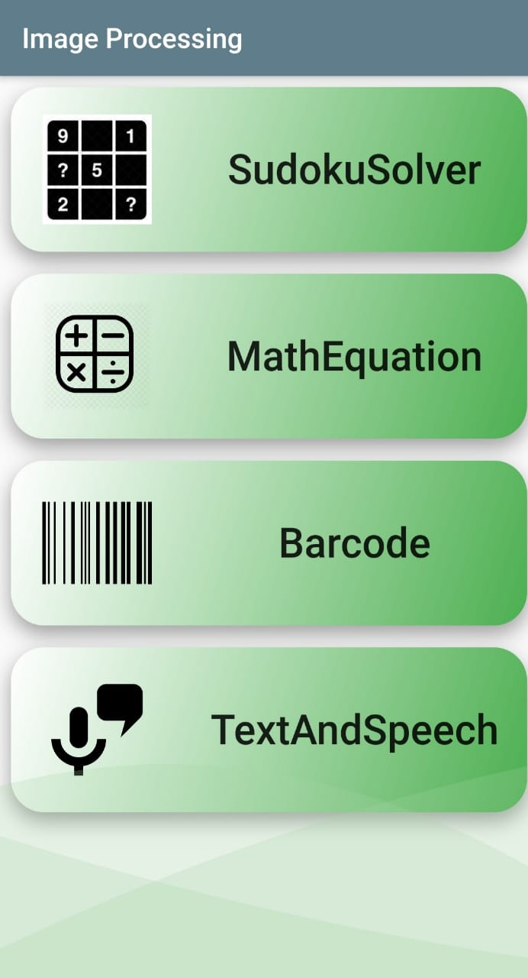

* Sudoku Solver View:

View contains two buttons to select image from camera or gallery. After selecting image, there will be solution of that Sudoku.

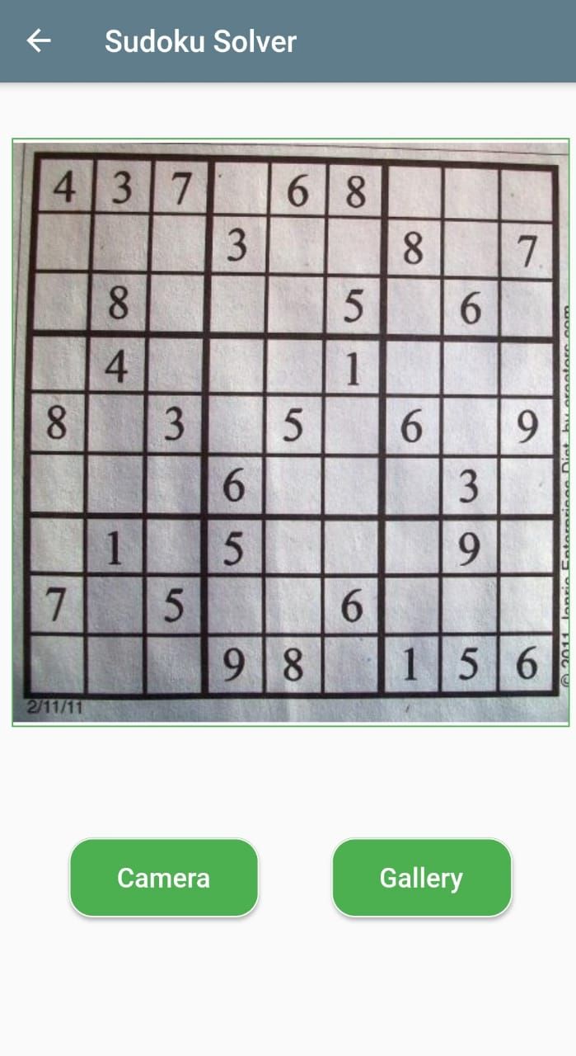

* Math Equation View:

View contains two buttons to select image from camera or gallery. After selecting image, there will be solution of the simple math equation provided.

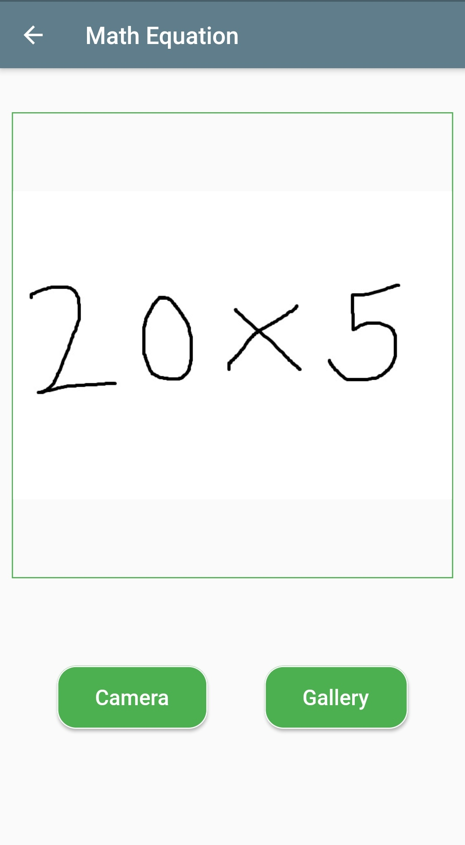

* Barcode View:

Similar to above view it contains two buttons, after selecting image the barcode is detected in image and if product details of barcode is present then it is shown in view else will show “NOT PRESENT” message.

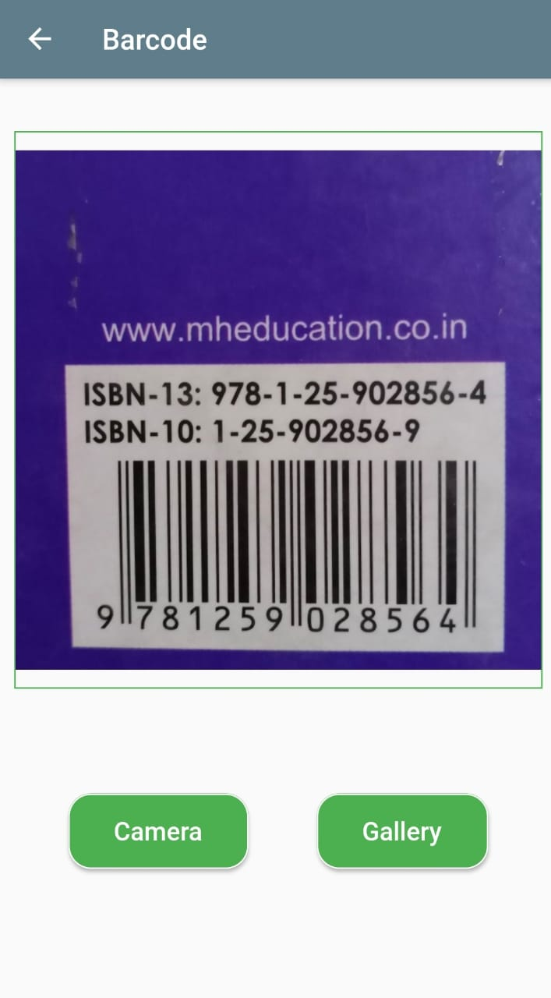

* Text and Speech View:

View is divided into three parts as Image View, Text View and Navigation panel with different buttons like mic, speaker, gallery and camera

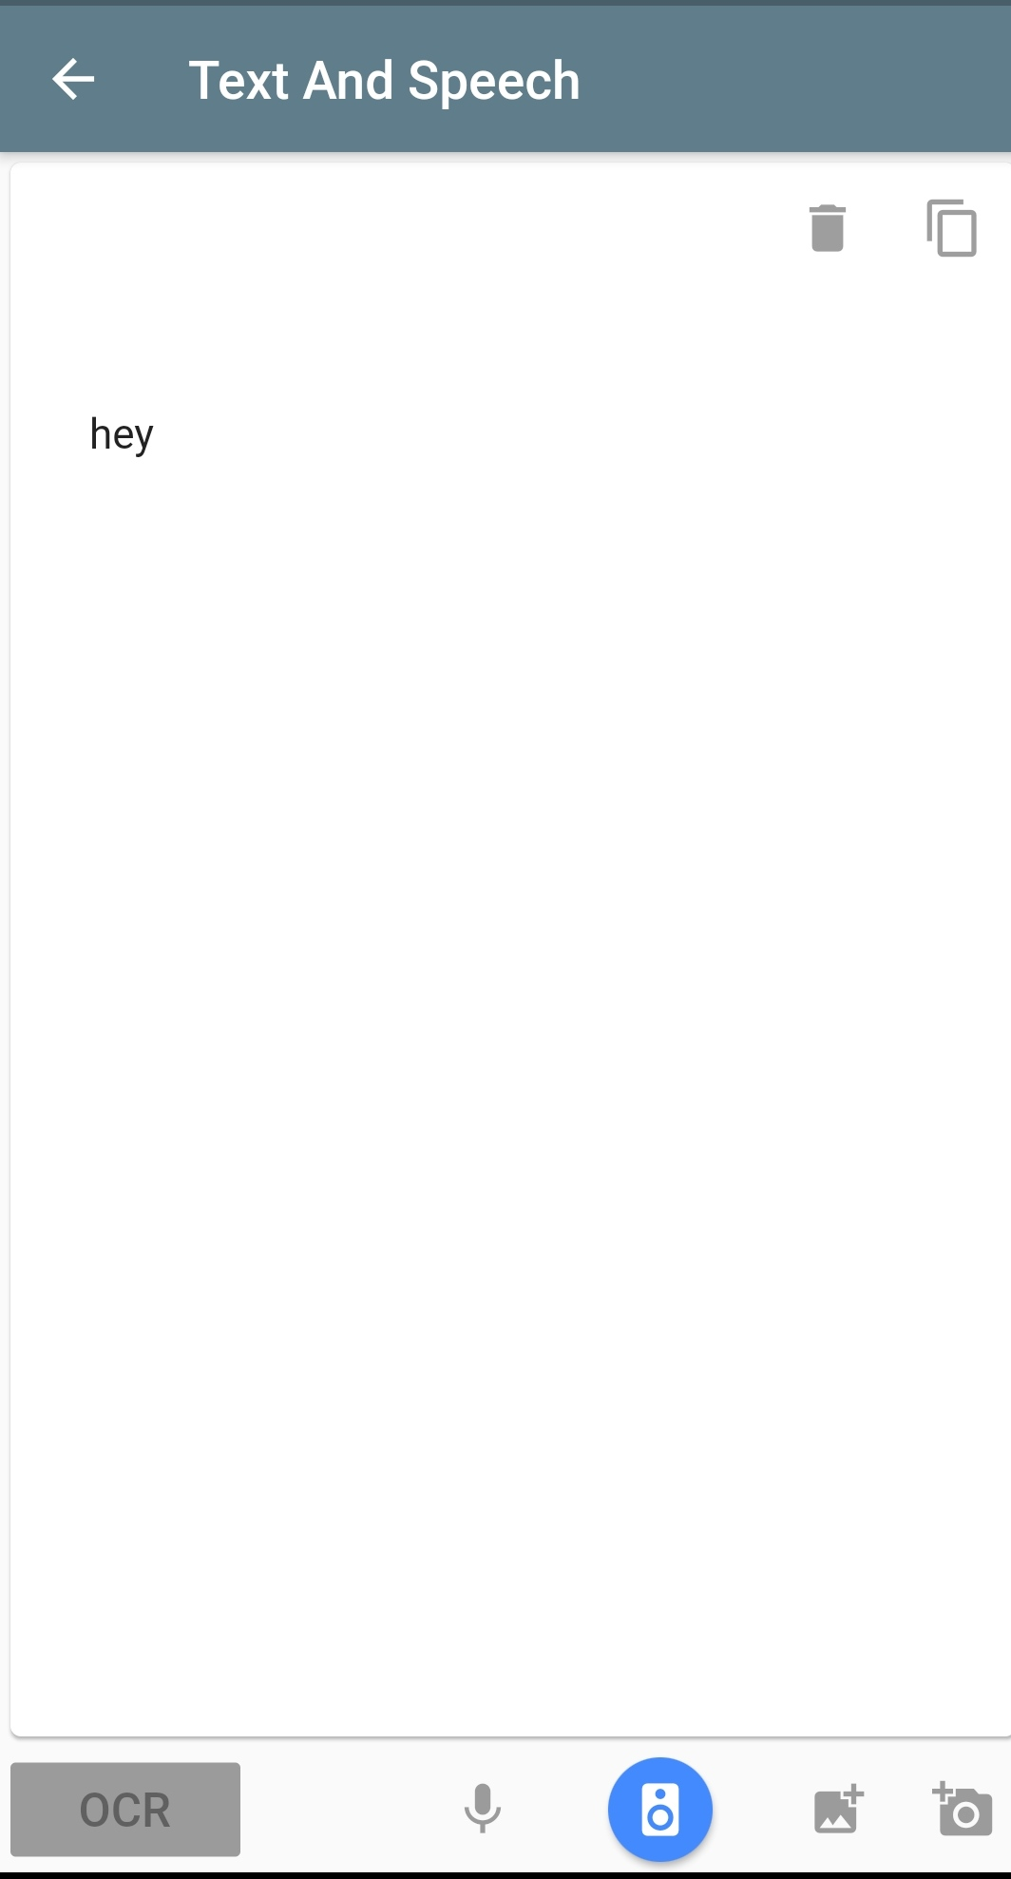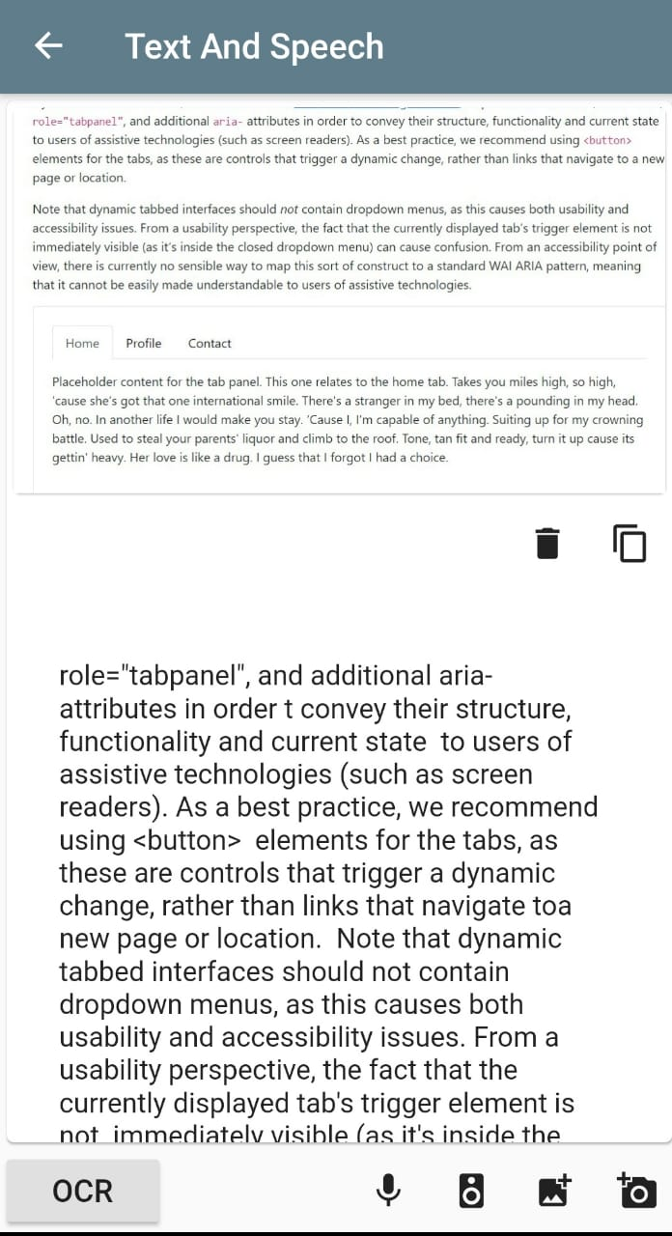

* Translator View:

View contains text box and two language selection options. On selection of language the text is translated to destination language.

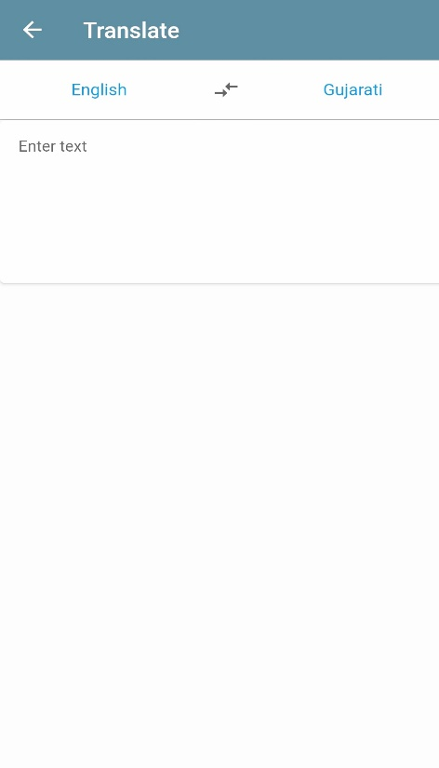 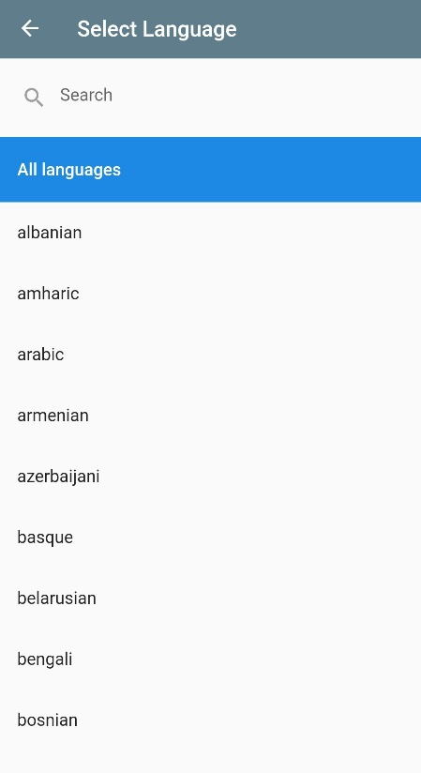

**5.2 Sub Project Implementation Details**

**1) Sudoku Solver**

**#Janak**

**2) Math Equation Solver**

**#Jayesh**

**3) Translator**

**#Harshit**

**4) Barcode to Product Details**

**#Jayesh**

**5) Image to Text**

**#Janak**

**6) Text Reader**

**#Janak**

**5.3 Flask Server as Backend**

* The Project is developed using python language. Functionalities involving ML and DL is done using Python. So we were required to access app endpoints using flutter. So Flask is used as backend server from where the functionalities are exposed through URL.
* To and Fro data transfer is done using JSON.

**Request**

**Flask**

**Response**

6. Testing

**#Jayesh and #Janak**

**6.1 Testing Method Used**

**6.2 Test Cases**

7. Screenshots

**Output Screenshots for each sub project:-**

**1) Sudoku Solver**

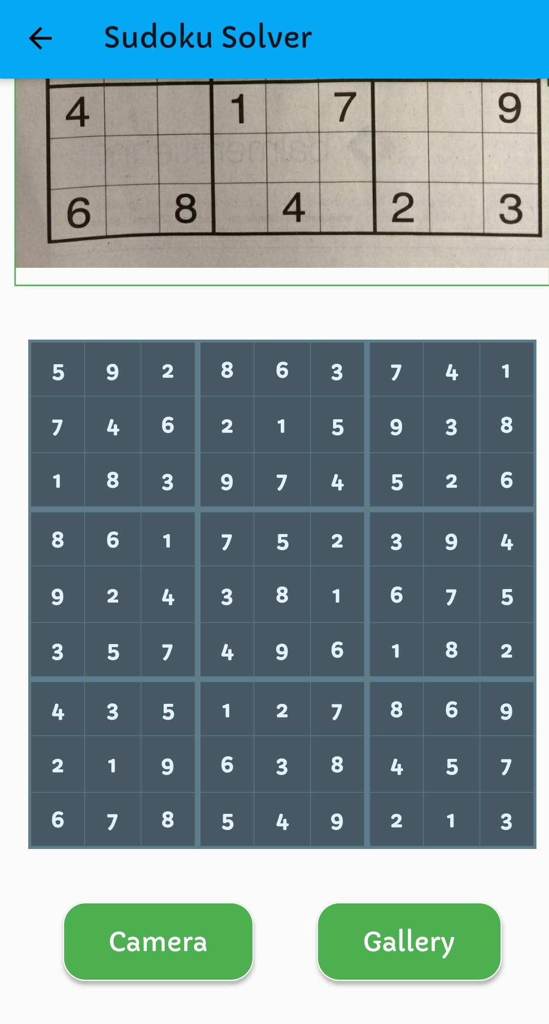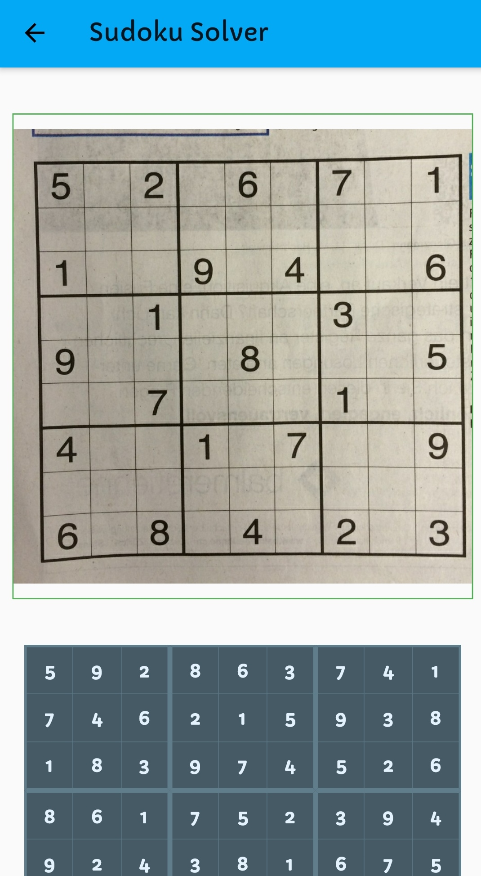

**2) Math Equation Solver**

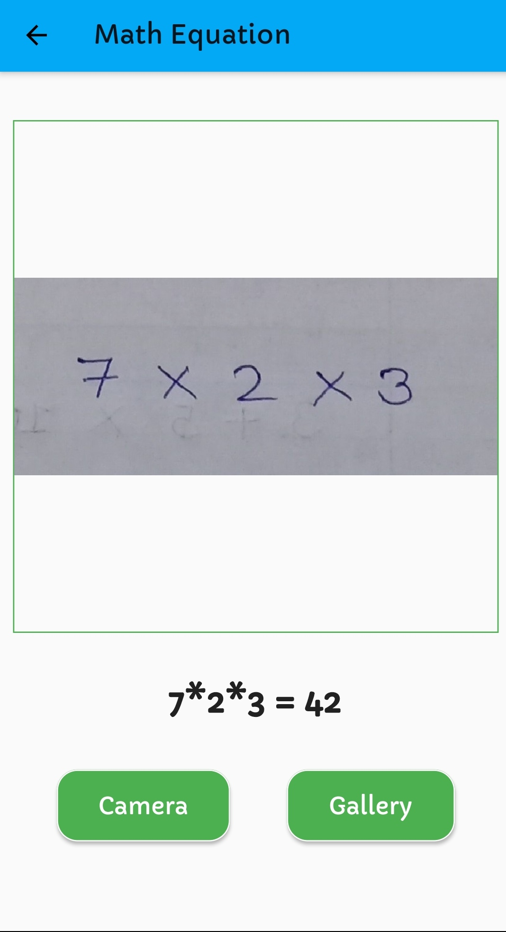

**3) Translator**

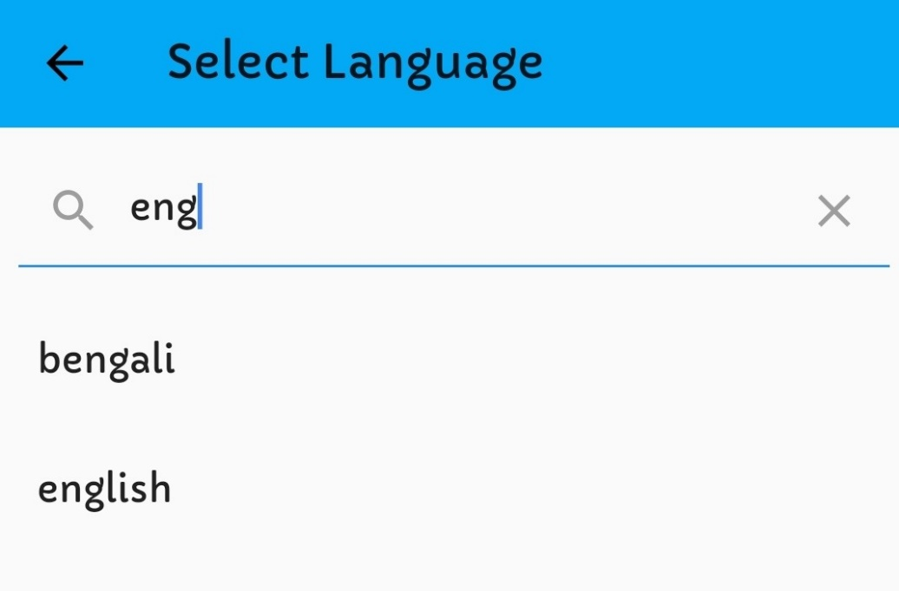

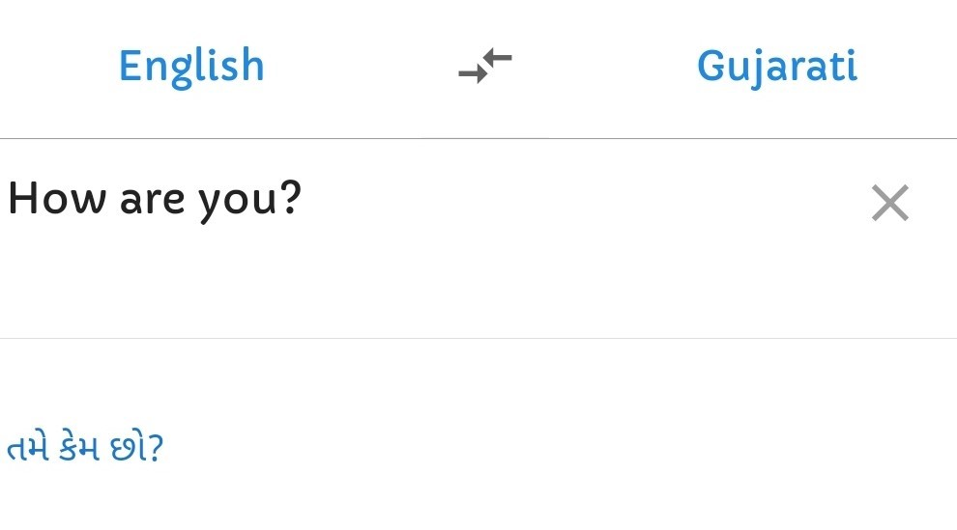

**4) Barcode to Product Details**

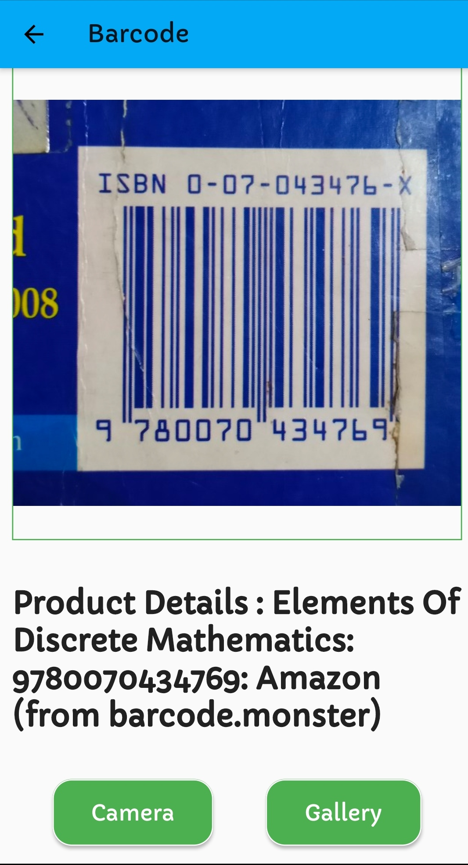

**5) Image to Text and Text Reader**

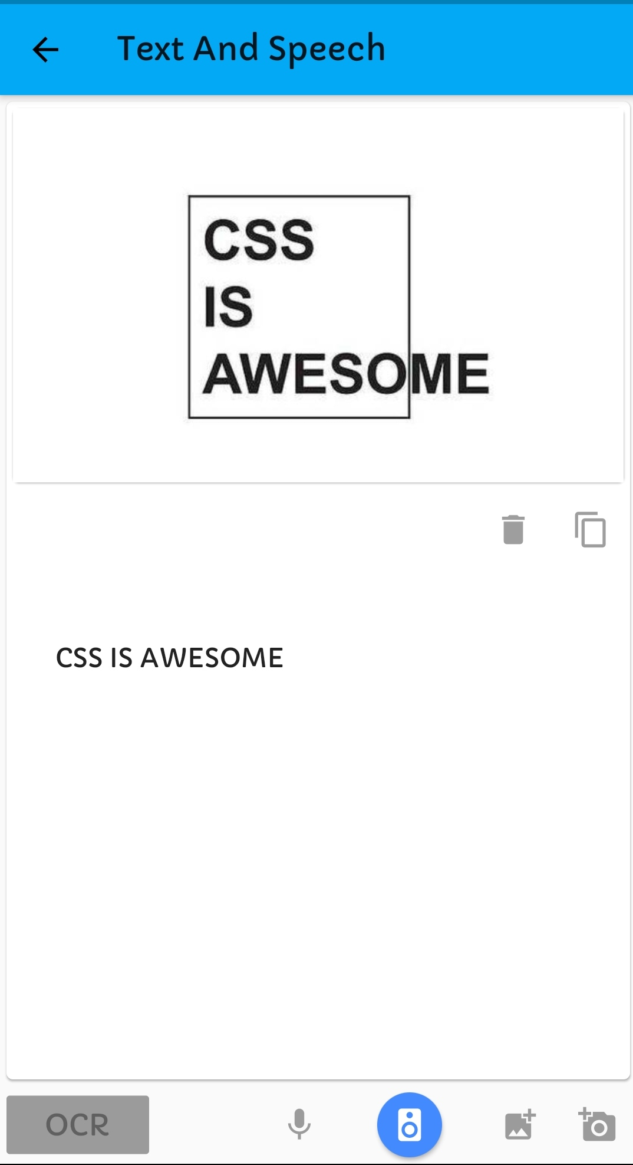

**6) Help**

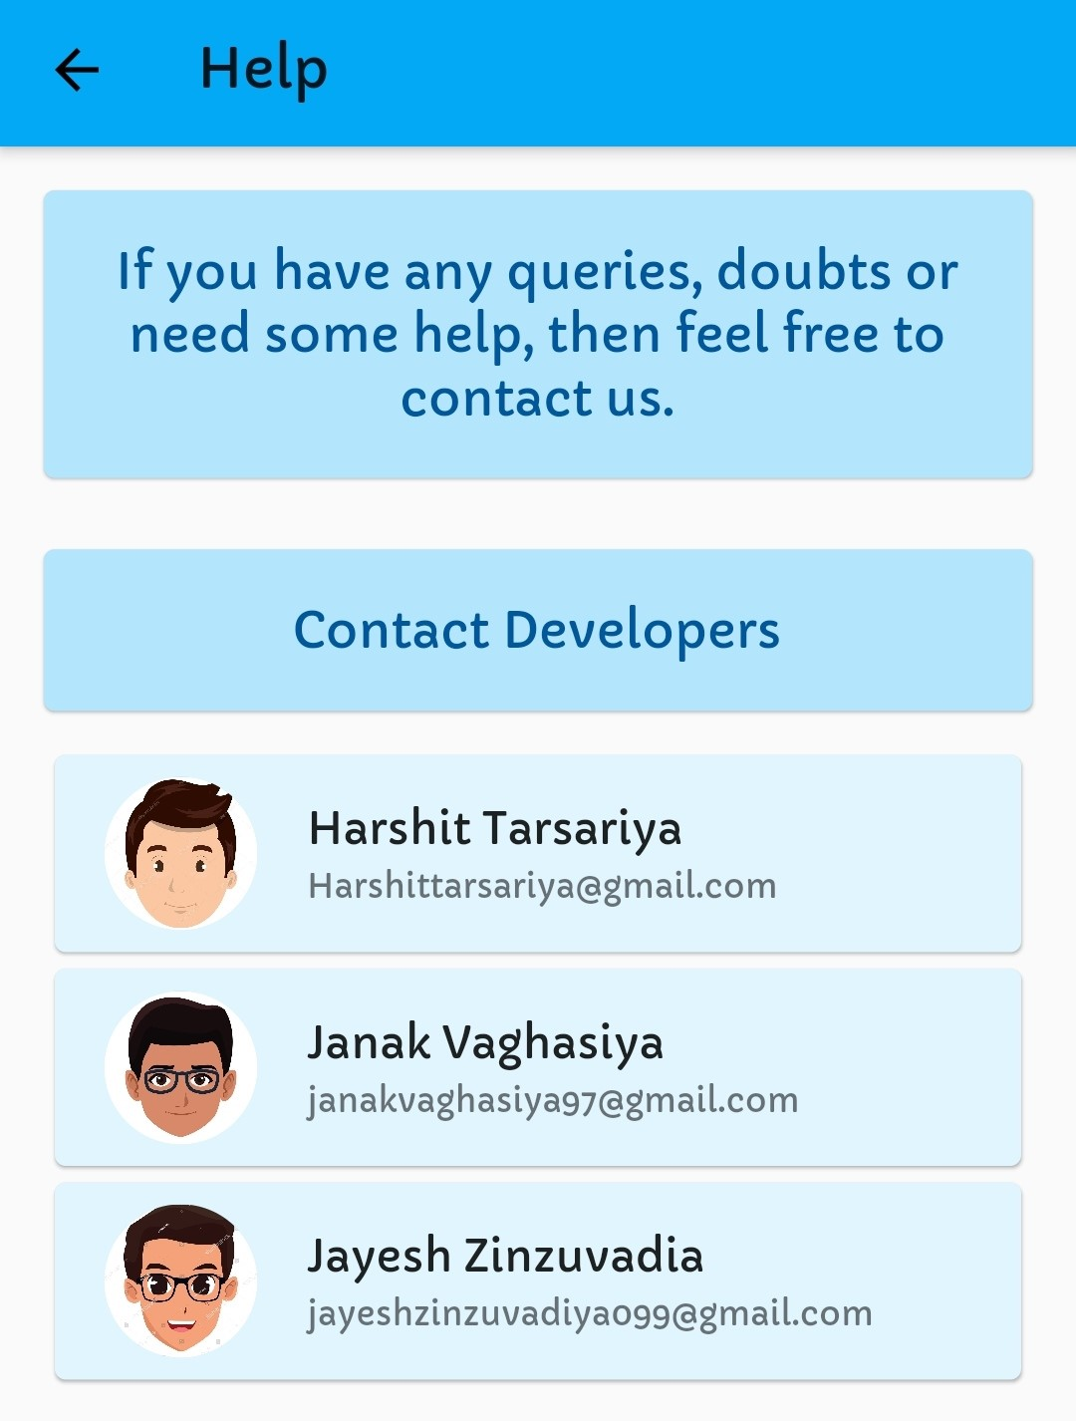

8. Conclusion

**#Jayesh**

**Write Conclusion here…**

9. Limitation and Future Extension

**#Jayesh**

**9.1 Limitation**

**9.2 Future Extension**

10. Bibliography

Following links and websites are referred during the development of this project:-

1. **For Sudoku Solver Project #Janak**

|  |  |
| --- | --- |
| **Description** | **References** |
|  |  |
|  |  |
|  |  |

1. **For Math Equation Solver Project #Jayesh**

|  |  |
| --- | --- |
| **Description** | **References** |
| Handwritten Math Symbols Datasets | <https://www.kaggle.com/xainano/handwrittenmathsymbols>  <https://www.kaggle.com/clarencezhao/handwritten-math-symbol-dataset> |
| GFG Article on Handwritten Equation Solver in Python | <https://www.geeksforgeeks.org/handwritten-equation-solver-in-python/> |
| OpenCV Python Tutorial for Beginners playlist by Programming Knowledge YouTube channel | <https://youtube.com/playlist?list=PLS1QulWo1RIa7D1O6skqDQ-JZ1GGHKK-K> |
| Handwritten Equation Solver by Vaibhavi Malik, DSC USICT YouTube channel | Part 1: <https://youtu.be/uMKF3bpH9Ec>  Part 2: <https://youtu.be/1VBuDk21J44> |
| Keras – Python Deep Learning Neural Network API playlist by deeplizard YouTube channel | <https://youtube.com/playlist?list=PLZbbT5o_s2xrwRnXk_yCPtnqqo4_u2YGL> |

1. **For Translator Project #Harshit**

|  |  |
| --- | --- |
| **Description** | **References** |
|  |  |
|  |  |
|  |  |

1. **For Barcode to Product Details Project #Jayesh**

|  |  |
| --- | --- |
| **Description** | **References** |
| How to detect QRCode and Barcode using OpenCV in Python by Murataza’s Workshop YouTube channel | <https://youtu.be/SrZuwM705yE> |
| Barcode Monster API for Fetching product details from Barcode Number | <https://barcode.monster/api/> |

1. **For Image to Text Project #Janak**

|  |  |
| --- | --- |
| **Description** | **References** |
|  |  |
|  |  |
|  |  |

1. **For Text Reader Project #Janak**

|  |  |
| --- | --- |
| **Description** | **References** |
|  |  |
|  |  |
|  |  |

Following links and websites are referred for creating this project report:- **#Jayesh**

|  |  |
| --- | --- |
| **Description** | **References** |
| Information about Image Processing – Used for abstract and introduction | <https://sisu.ut.ee/imageprocessing/book/1> |
|  |  |
|  |  |